**PRACTICAL 3**

Analyze the memory dump of a running computer system. Extract volatile data, such as open processes, network connections, and registry information.

1)Overview

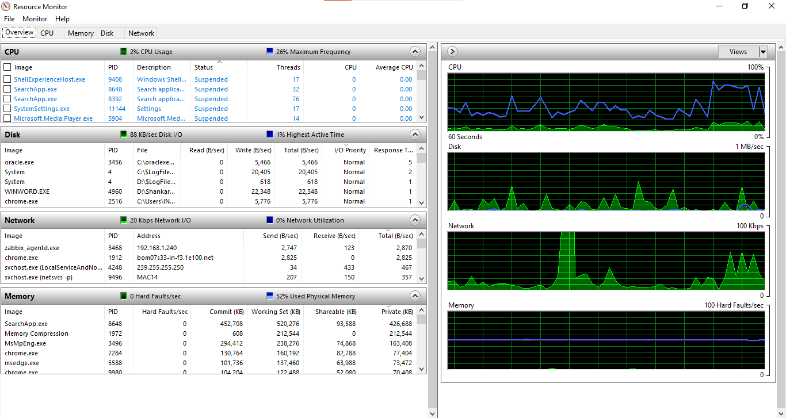

2)CPU

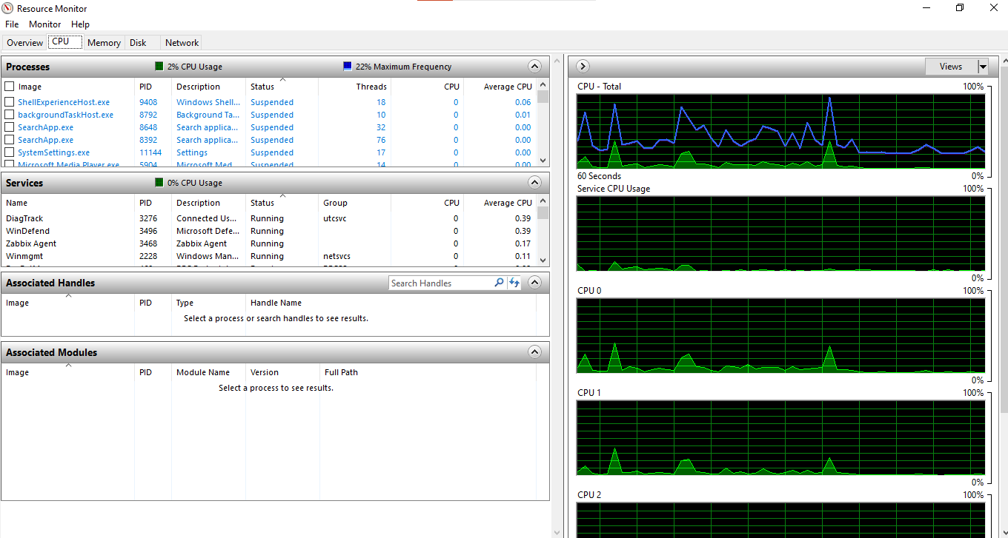

3)Memory

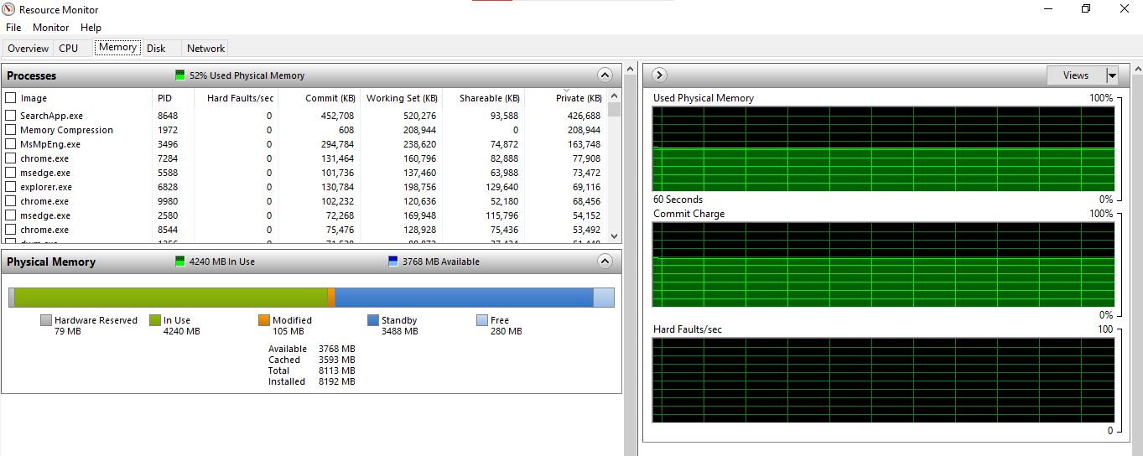

4)Disk

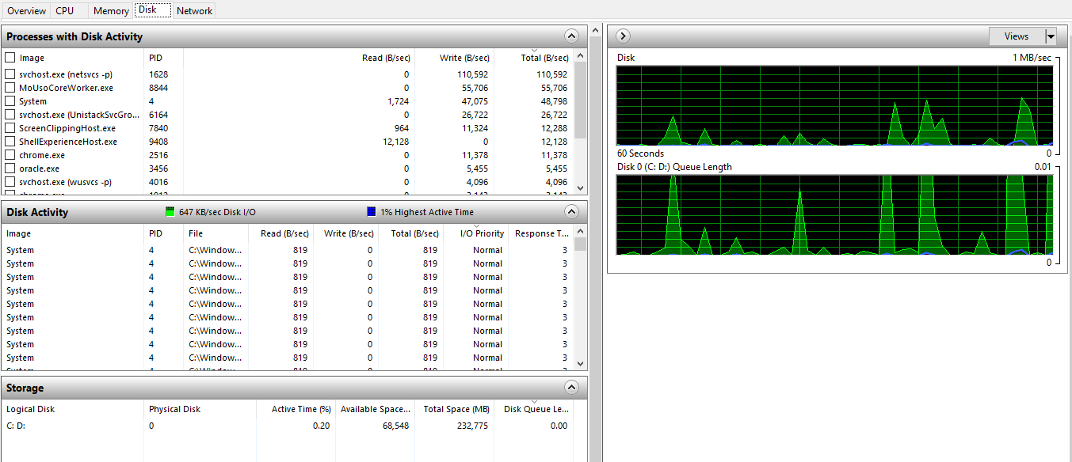

5)Network

